Module 10 – MOLP

Exploratory Data Analysis

*In this section, you should perform some data analysis on the data provided to you. Please format your findings in a visually pleasing way and please be sure to include these cuts:*

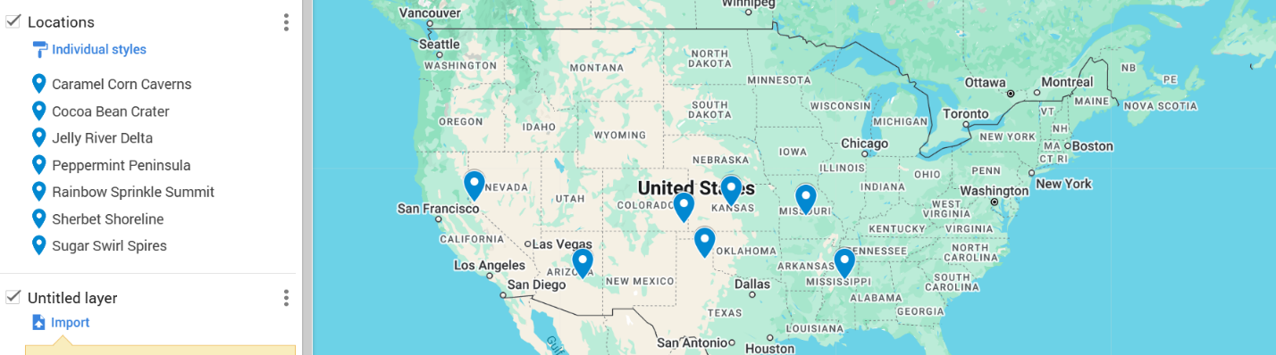

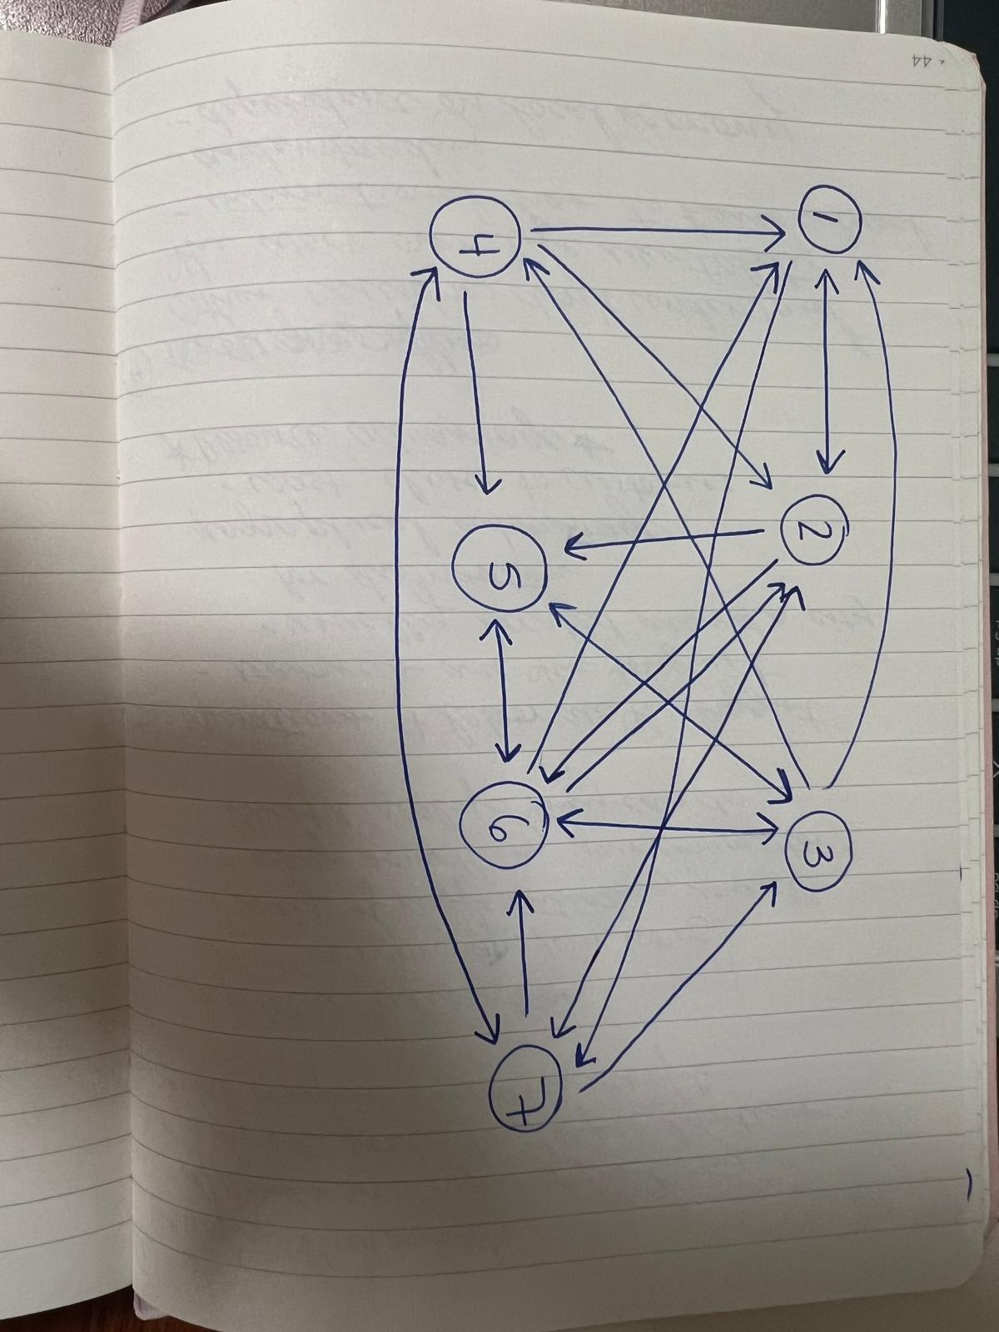

Model Formulation

*Write the formulation of the model into here prior to implementing it in your Excel model. Be explicit with the definition of the decision variables, objective function, and constraints. For this problem, I am only asking that you perform the model formulation for the MOLP model.*

Objectives:

Total Transportation Cost: MIN = 5X12 + 21X17+15X21 + 17X25 + 10X26 + 22X27 + 23X31 + 11X34 + 6X35 + 17X36 + 19X41 + 6X42 + 19X45 + 19X47 + 24X53 + 14X56 + 12X61 + 7X62 + 10X63 + 17X65 + 23X72 + 23X73 + 5X74 + 8X76

Total Congestion: MIN = 0X12 + 1X17+1X21 + 1X25 + 1X26 + 1X27 + 1X31 + 1X34 + 1X35 + 1X36 + 1X41 + 1X42 + 1X45 + 1X47 + 1X53 + 1X56 + 1X61 + 1X62 + 1X63 + 0X65 + 1X72 + 0X73 + 1X74 + 1X76

Total Eco-Friendly: MIN = 1X12 + 0X17+1X21 + 1X25 + 0X26 + 1X27 + 1X31 + 0X34 + 1X35 + 1X36 + 1X41 + 1X42 + 1X45 + 1X47 + 1X53 + 1X56 + 1X61 + 1X62 + 1X63 + 0X65 + 1X72 + 1X73 + 1X74 + 1X76

Total Distance Cost: MIN = 17X12 + 3X17+17X21 + 27X25 + 31X26 + 19X27 + 9X31 + 13X34 + 19X35 + 21X36 + 4X41 + 21X42 + 6X45 + 4X47 + 19X53 + 5X56 + 14X61 + 31X62 + 21X63 + 5X65 + 19X72 + 10X73 + 4X74 + 12X76

Constraints:

X1j<=9759, X2j<=1455, X3j<=1762, X4j<=1214, X5j<=1982, X6j<=1559, X7j<=1787

Xi2>=1455, Xi3>=1762, Xi4>=1214, Xi5>=1982, Xi6>=1559, Xi7>=1787

Xij>=0

Model Optimized for Equally Weighted Objectives

*Implement your formulation into Excel and be sure to make it neat. This section should include:*

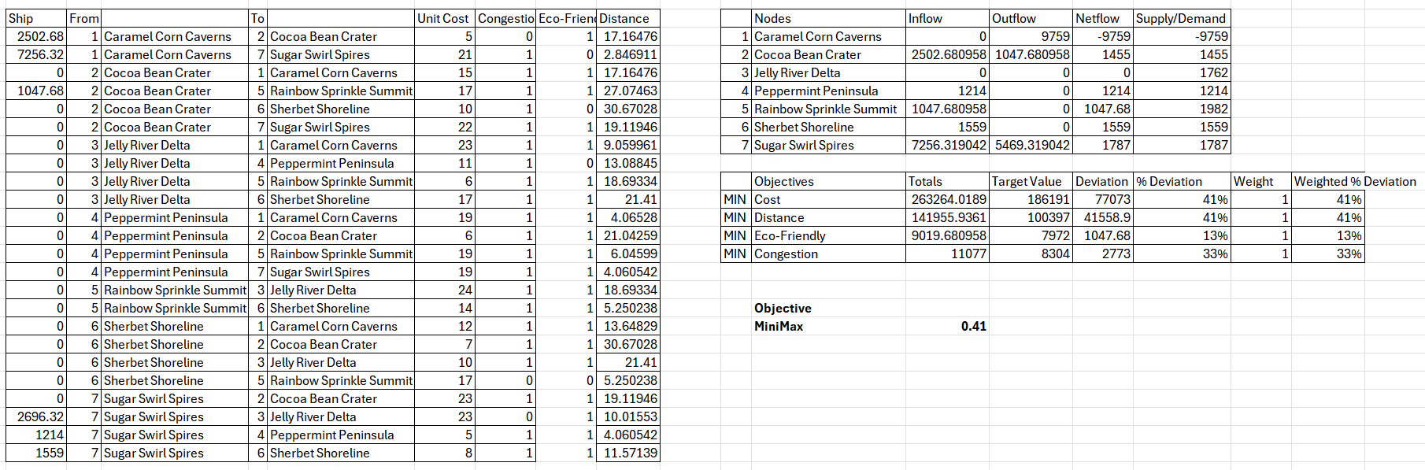

The model is recommending 6 different paths to optimize the transportation of goods while minimizing costs, distances, environmental impact, and congestion. X12, X17, X25, X73, X74, X76 are the most optimal for this problem.

Model with Stipulation

*Alter the weights of each objective to add weight to match what matters most to you. Perhaps run a few different scenarios to see how the routes change depending on the weights. When you find a weight mix and solution that satisfies you, please write a justification on why you chose the final model/weights and about how a configured model like yours can be used for scenario planning.*

When you increase the weight to 5, the minimax increases to 2.07 and some routes change. When you decrease the weight to 0.5, the minimax decreases and the routes change as well. The final model I chose is the original model as it seems fair to have a weight at 1, but I believe ideally it would be better to have a greater weight for a stronger emphasis on the objectives